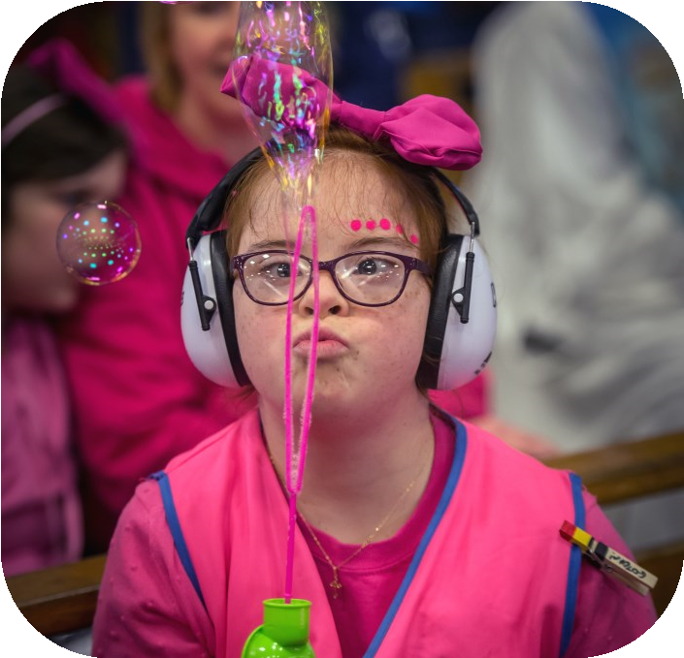

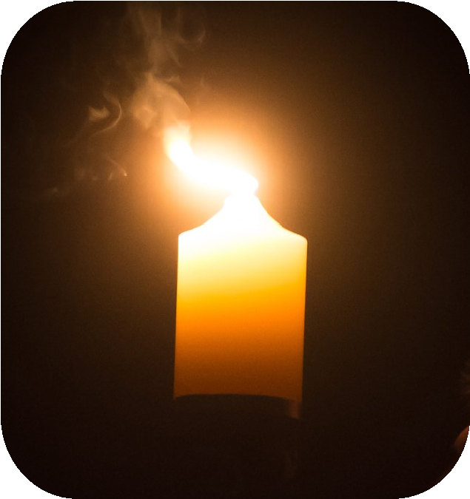
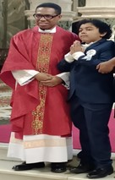
Caritas St Joseph
’
s aims to enable people with learning
disabilities to participate fully in the life of their church
and community.

The Workshop will enable you to:

•
Develop an understanding of faith formation for people with learning
disabilities
•
Understand how people with learning disabilities can be prepared to
celebrate the sacraments of baptism, first communion, and confirmation
•
Share experiences of good practice
•
Be introduced to diocesan resources
Thursday 19th

September 2024

6
pm
—

8
pm
Vaughan House
46
Francis Street
London SW1P

1
QN
For further Information and booking please contact
Finola Ryan .finolaryan
@rcdow.org.uk / 07525

812518
OR Paul Christian
paulchristian
@rcdow.org.uk / 0
7854 768336
www.stjoseph.org.uk

Registered Charity No. 233699
Symbols of Faith
Preparing parents, priests and catechists to work with

people with learning disabilities

