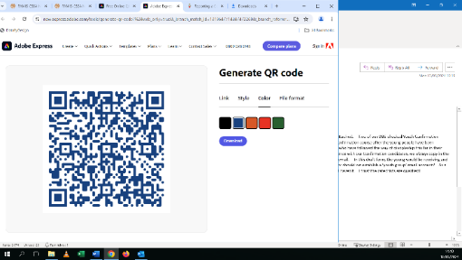



**If you are concerned about the immediate safety of a child or adult at risk, please telephone the police on 999.** You can also contact the Police on **101** or your local children or adult services via your local Council website without delay.

**Creating a Culture of Safeguarding**

***The Diocese takes a zero-tolerance approach.***

*This means that any abuse of children and vulnerable adults under the supervision or care of clergy, religious, Church volunteers, employees or persons involved in Church activities will not be tolerated.*

*Such behaviour is contrary to the Gospel and to the Church’s mission, stated values and ideals, which require that everyone must be treated with dignity, courtesy and respect.*

**Safe Spaces 0300 303 1056 • Childline: 0800 1111**

**Samaritans: 116 123 • Family Lives: 0808 800 2222**

**NSPCC: 0808 800 5000 • Respect Phoneline: 0808 8024040**

**NAPAC: 0808 801 0331 • National Careline: 0800 0699 784 Hourglass: 0808 808 814 • The Survivors Trust: 0808 801 0818**

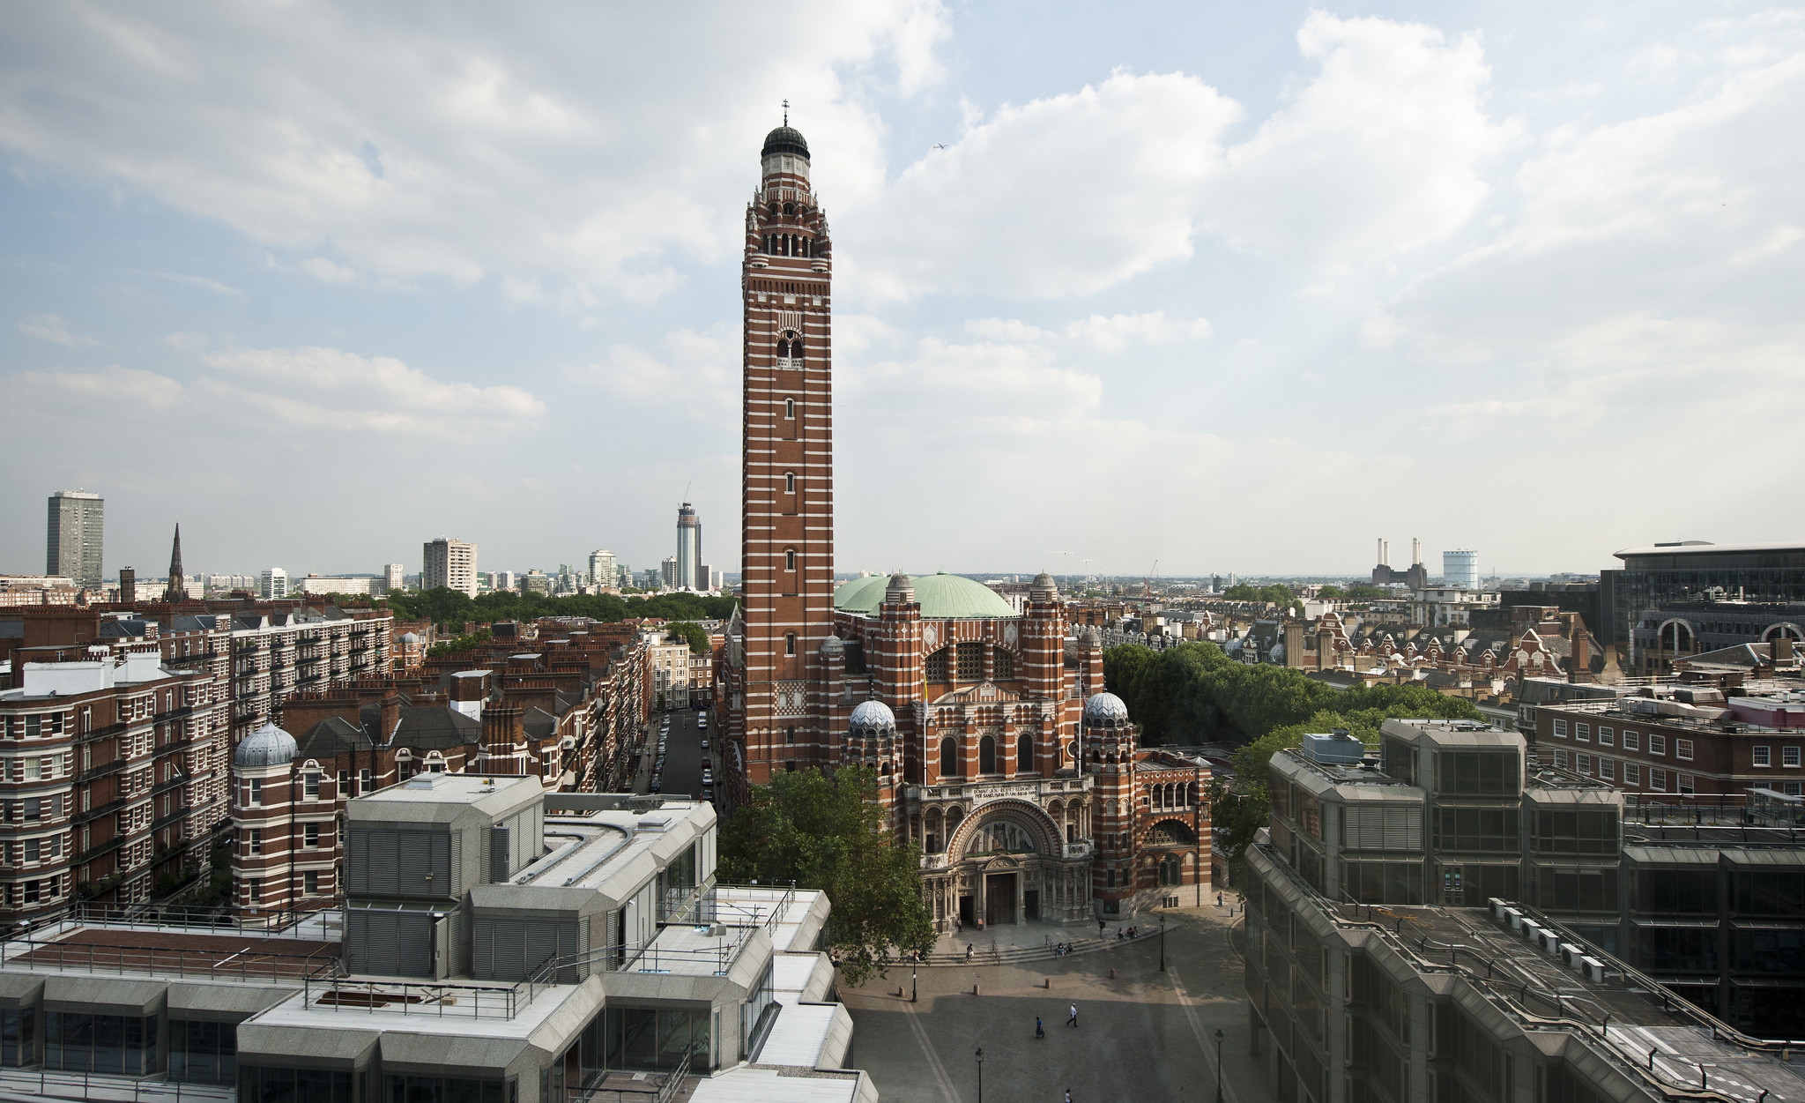

**The Diocesan Safeguarding Service can be contacted on:**

**020 7798 9352**

**To report any safeguarding concerns, past or present: (option 1) or safeguarding@rcdow.org.uk**

**Safer recruitment and DBS: (option 2) or dbsadmin@rcdow.org.uk**

**Safeguarding training & all other queries: (option 4) or safeguardingadmin@rcdow.org.uk**

**Scan to go to RCDOW**

**Safeguarding website:**

**Your Parish Safeguarding Representatives are:**

**Insert Name**

**safeguarding@rcdow.org.uk**

**Insert Name**

**safeguarding@rcdow.org.uk**

**Insert Name**

**safeguarding@rcdow.org.uk**