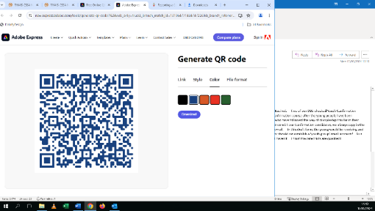



**If you are concerned about the immediate safety of a child or adult at risk, please telephone the police on 999.** You can also contact the Police on **101** or your local children or adult services via your local Council website without delay.

**Creating a Culture of Safeguarding**

***The Diocese takes a zero-tolerance approach.***

*This means that any abuse of children and vulnerable adults under the supervision or care of clergy, religious, Church volunteers, employees or persons involved in Church activities will not be tolerated.*

*Such behaviour is contrary to the Gospel and to the Church’s mission, stated values and ideals, which require that everyone must be treated with dignity, courtesy and respect.*

**NSPCC: 0808 800 5000 • Childline: 0800 1111**

**Family Lives: 0808 800 2222 • Samaritans: 116 123**

**Respect Phoneline: 0808 8010 327 • NAPAC: 0808 801 0331**

**National Domestic Abuse Helpline: 0808 2000 247**

**National Careline: 0800 0699 784 • Stop It Now: 0808 1000 900**

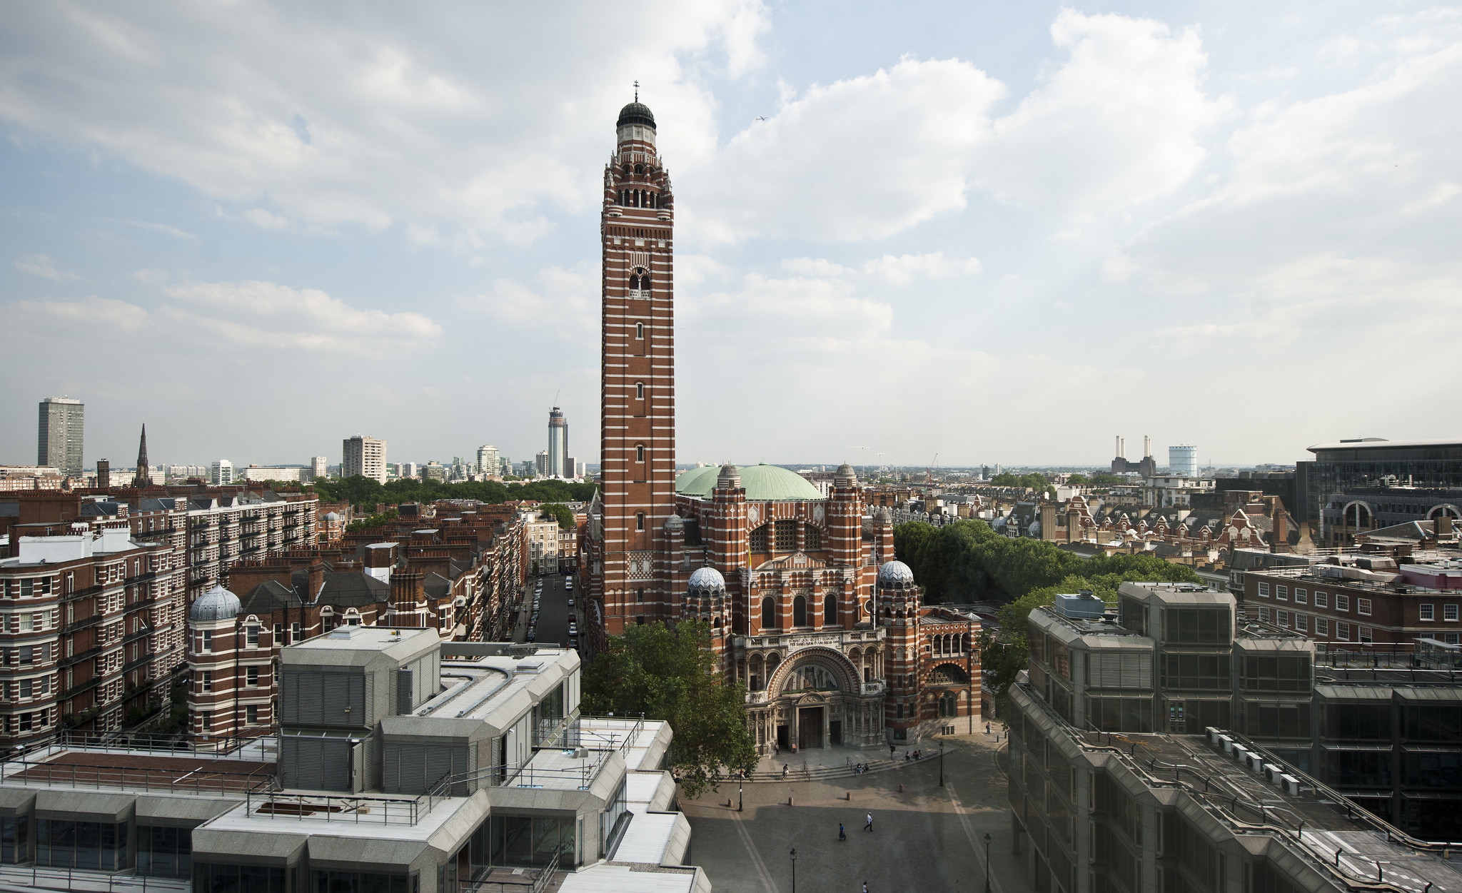

**The Diocesan Safeguarding Service can be contacted on:**

**020 7798 9352**

**To report any safeguarding concerns, past or present: (option 1) or safeguarding@rcdow.org.uk**

**Safer recruitment and DBS: (option 2) or dbsadmin@rcdow.org.uk**

**Safeguarding training & all other queries: (option 4) or safeguardingadmin@rcdow.org.uk**

**Scan to go to RCDOW**

**Safeguarding website:**

**Your Parish Safeguarding Representatives is:**

**Insert Name**

**safeguarding@rcdow.org.uk**