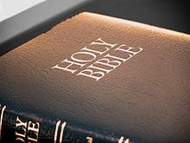

Blessing of Bibles

Order of Blessing within Mass

Prayer of Blessing

The assembly is invited to hold up their copies of the Bible.
With hands extended over the assembly the celebrant says:

Everlasting God,
when he read in the synagogue at Nazareth,
your Son proclaimed the good news of salvation
for which he would give up his life.
Bless all who will read from these sacred texts.
As they read, listen and reflect on your words of life,
strengthen their faith
so that what they read in hope,
they may live in love and charity.
We ask this through Christ our Lord.
Amen.

(Prayer based on Order of Blessing of Readers, Book of Blessings)

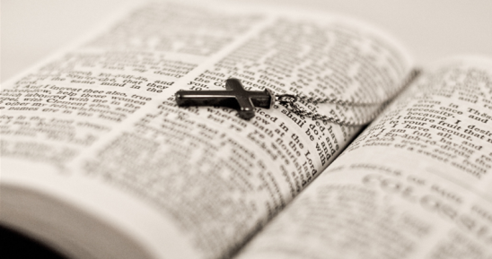

Notes on Blessing of Bibles

Introduction
- To encourage the faithful to own a copy of the Bible and to read it prayerfully they might be invited to bring their Bibles to Mass for them to be blessed.
- People should be encouraged to bring any edition or even a part such as the Gospels.
- It would be appropriate for the parish to provide those who do not come with a text, and may not have a bible, with a copy of the Gospel for the current liturgical year, for example.
- In the homily the priest or deacon may speak on the importance of scripture in the life of the Church, different approaches to reading scripture and on the particular readings of the celebration. He may even invite people to find the Gospel text of the day in their own bible.
- The blessing takes place after the Prayer of the Faithful (some sample intercessions are given below).
- It would be suitable to celebrate this blessing on the Sunday of the Word of God (3rd Sunday in Ordinary Time). To celebrate it well will require an invitation in the weeks before and the ordering of any Gospels to be given out.

Order of Blessing within Mass

Prayer of Blessing

The assembly is invited to hold up their copies of the Bible.
With hands extended over the assembly the celebrant says:

Everlasting God,
when he read in the synagogue at Nazareth,
your Son proclaimed the good news of salvation
for which he would give up his life.
Bless all who will read from these sacred texts.
As they read, listen and reflect on your words of life,
strengthen their faith
so that what they read in hope,
they may live in love and charity.
We ask this through Christ our Lord.
Amen.
(Prayer based on Order of Blessing of Readers, Book of Blessings)

Some Notes

Blessing
The theology presented in the Book of Blessing is that God is the focus of our blessing —it is God whom we bless. We bless God for the gift of the object to be blessed and that those who use it will grow in their love of God and neighbour.

Model Intercessions
- For all who read the word of God;
may they be inspired to love God with all their heart and soul.
- For all who pray with the word of God;
may their lives be living witness to the way of the Lord.

